**Act 2, Scene 3**  
*Romeo and Friar Laurence*From the Graphic Novel

1. Which line on page 1 is an example of *foreshadowing*? Make a prediction about how Romeo and/or Juliet will die based on this example of foreshadowing.
2. Describe the relationship between Romeo and Friar Laurence. Provide *evidence* from the text/image to support your conclusions.
3. How does Friar Laurence react to hearing of Romeo’s new love? What is his opinion on his new relationship with Juliet. Cite the line from his dialogue that is most revealing of his attitude.
4. What reason does Friar Laurence give for agreeing to marry Romeo and Juliet?
5. If Romeo and Juliet get caught by their parents, should Friar Laurence be held partially responsible because he helped them be together? Why or Why not?

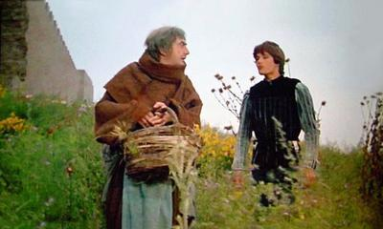

**Act 2, Scene 3**  
*Romeo and Friar Laurence*From the Graphic Novel

1. Which line on page 1 is an example of *foreshadowing*? Make a prediction about how Romeo and/or Juliet will die based on this example of foreshadowing.
2. Describe the relationship between Romeo and Friar Laurence. Provide *evidence* from the text/image to support your conclusions.
3. How does Friar Laurence react to hearing of Romeo’s new love? What is his opinion on his new relationship with Juliet. Cite the line from his dialogue that is most revealing of his attitude.
4. What reason does Friar Laurence give for agreeing to marry Romeo and Juliet?
5. If Romeo and Juliet get caught by their parents, should Friar Laurence be held partially responsible because he helped them be together? Why or Why not?

