Allegory
- From the Greek __________________ meaning ___________________________________
- An allegory is a complete __________________, __________________, or __________________ that may be interpreted to have a ________________________________.
- One meaning is __________________, or _________________________.
- The other meaning is __________________, or __________________.
- This hidden meaning is connected to the _____________________________________________ message or __________________ the author is trying to convey.
Jan Brueghel painting
Allegory of _________
Figurative:
Hidden
Literal:
On-the- surface
What do you see?

What could it mean?

Another Example:
Fill out the chart below,
then write a name for
this piece of art that
expresses its hidden
meaning.
Titled:
___________________
Figurative:
Hidden
Literal:
On-the- surface
What do you see?

What could it mean?

Elements of Allegory
- An allegory is a form of ______________________________.
- A ________________ is a ________________ between two things used in literature to ________________ things about something an author is describing.
- Unlike a ________________, a metaphor doesn’t use the words ___________ or ________.
Elements of Allegory: Symbolism
- The author uses ________________ to help ________________ the message or theme in an allegory.
- A ________________ is an ____________________________________________that is used to ________________ something else.
  - Examples:
Symbol: | Represents:
Symbol: | Represents:
Symbol: | Represents:
Add your own: | Represents:

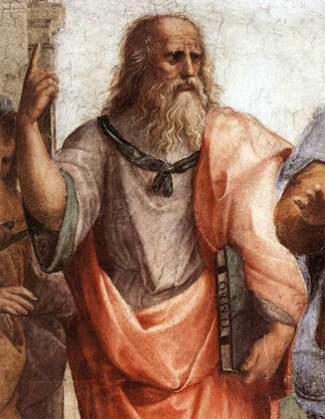
Plato’s Allegory of “The Cave”
- Plato was a _________________
- He studied under
_________________ and he taught _________________
- Philosophy is the art of
_____________________________
“The Cave”
Figurative:
Hidden
Literal:
On-the- surface
What happened?

What Plato be saying about life?

