Biographical Museum Display
English 9 Independent Reading Project
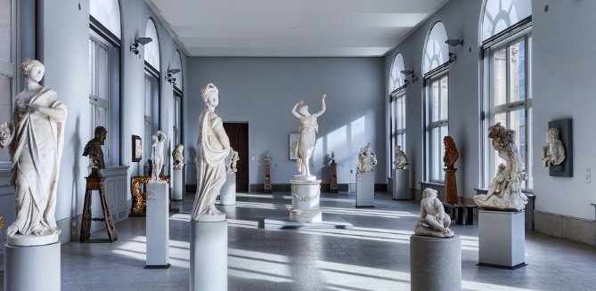
After several nerve wracking interviews and hours of studying guide books, you have finally gotten hired as curator at the Museum of Fascinating and Significant Lives. The only problem? Your first assignment is on an individual you know nothing about! Not to worry! Perseverance is what got you this job in the first place! You quickly run to the bookstore to search for research materials that will help you formulate a plan!
Assignment: Choose an autobiography, biography, or memoir and create an in-depth display depicting the significant factors that contributed to the shaping of the individual’s identity.
Display Parameters:
- Space allotted: One desk and one chair
- Self-standing display (ex. Trifold display board)
- Decorated with a theme appropriate to the subject and their significance
- Portrait and Full Name of the Individual along with any nicknames or titles
- Brief description of why this person’s life is fascinating and significant
- At least 3 two-dimensional images attached to the self-standing display representing significant events/experiences/people that shaped the subject’s identity, beliefs, and/or values
- A description that accompanies each image including an explanation as to what the image represents and how it influenced the subject, as well as a direct quote from the biography that supports this description. The quote should be integrated smoothly into the description and punctuated appropriately. (These are also attached to the self-standing display.)
- MLA Citation for the book used as a source (accurately written)
- Your Name and Class Period
ADDITIONAL REQUIREMENT FOR HONORS COURSES:
- 1 three-dimensional, hands-on item that represents a significant event/experience/or person that shaped the subject’s identity, beliefs, and/or values. The item will also need a written explanation with a supporting quote from the text that can either be attached to the full display, or standalone next to the object.
Your object can be homemade or store bought, but you will be scored on creativity, so think outside the box! This should be something that museum goers can pick up, so if you make it yourself, keep that in mind!
Name: _____________________________________ Pd. _________
SCORING RUBRIC
(TURN IN WITH PROJECT)
Final Assignment Due: _________ Gallery Walk: _________ Planning Due: _________
Scoring Element | Item | Score
Planning | Turned in on Time | /5
Visual  Display | Subject’s Name and Portrait | /2
 | Description of Subject | /2
 | Visual Aesthetic | /5
 | MLA Citation | /5
 | Stands up by itself | /1
Image 1 | Present and connects to identity/beliefs/values | /2
 | Visual Aesthetic | /5
 | Written Explanation | /5
 | Supporting Quote | /5
 | Conventions | /3
Image 2 | Present and connects to identity/beliefs/values | /2
 | Visual Aesthetic | /5
 | Written Explanation | /5
 | Supporting Quote | /5
 | Conventions | /3
Image 3 | Present and connects to identity/beliefs/values | /2
 | Visual Aesthetic | /5
 | Written Explanation | /5
 | Supporting Quote | /5
 | Conventions | /3
HONORS ONLY
3d Object | Present and connects to identity/beliefs/values | /2
 | Visual Aesthetic | /5
 | Written Explanation | /5
 | Supporting Quote | /5
 | Conventions | /3
TOTAL SCORE:
Name: _____________________ ENG 9 Pd. ______
Biographical Museum Display: PLANNING
English 9 Independent Reading Project
Subject’s Name: _______________________________
Title and Author of Book: _________________________________________________________________
MLA Citation:
__________________________________________________________________________________________________________________________________
Nicknames/Titles: ___________________________________________________
Rough Draft Description of Individual:
Image 1 Idea: _______________________________________________________
Description: | Supporting Quote:

Image 2 Idea: _______________________________________________________
Description: | Supporting Quote:
Image 3 Idea: _______________________________________________________
Description: | Supporting Quote:
(HONORS ONLY) 3D Object Idea: _________________________________________________________________
Description: | Supporting Quote:
Ideas for display board decorations:

