[](https://www.google.com/url?sa=i&rct=j&q=&esrc=s&source=images&cd=&cad=rja&uact=8&ved=&url=https://icons8.com/icon/6893/flowers&psig=AOvVaw0n66d90TEz0YsVXXmY7Vgs&ust=1523575709146224)[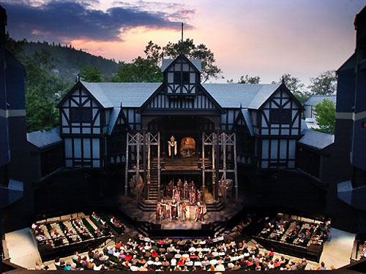](https://www.google.com/url?sa=i&rct=j&q=&esrc=s&source=images&cd=&cad=rja&uact=8&ved=2ahUKEwjc0oS1orPaAhUGMd8KHfokCQMQjRx6BAgAEAU&url=http://elizabethanenglandlife.com/elizabethan-bear-garden-theatre.html&psig=AOvVaw1QGomw0DN4ODkDQha6_B7x&ust=1523572065687142)

* Why Theatre?
  + Lack of entertainment
  + Every social class made an appearance
  + People put theatre before their jobs
* Attending the Theatre
  + Looked down on the theatre because...
    - Unsanitary
    - Rowdy Audience
  + Live performances
  + Women weren’t accepted in the theatre atmosphere
* Life of an Actor
  + Passionate and Dedicated
    - Celebrities of this era
  + Actors were stakeholders
  + Only men were allowed in the theatre until 1660

[](https://www.google.com/url?sa=i&rct=j&q=&esrc=s&source=images&cd=&cad=rja&uact=8&ved=2ahUKEwiwobmXr7PaAhXSTN8KHctzAIoQjRx6BAgAEAU&url=https%3A%2F%2Fwww.shareicon.net%2Fmovie-clapperboard-clapper-cinema-movies-cinema-icons-701903&psig=AOvVaw2to1GXVln_oEnoRaTkP3WS&ust=1523575160044809)

by: Carmen Broadwater

Rebecca Dartious, &

Gage Sabator

Elizabethan Theatre