Elizabethan Era: Theater Life
- Day to Day Life:
- Communication, Performances, Beliefs, Popularity
- Who Attended
- Interest, Audience, when people attended
- What was it like?
- Appearance, Feeling
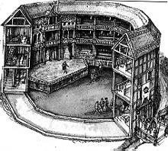
- Compared to present day theater
- Day in the Life of an Actor
- Lifestyle, Expectation
- Activities
- Social Status
- Popular Playwrights
- Plays
- Theatres
- Video

