Mercutio: The Comedian Name: _____________
Shakespeare Uncovered
- Dominic Drumgoole describes Romeo and Juliet’s Verona as “a big social world”. How does he say Shakespeare’s play functioned within this social world?
_____________________________________________
_____________________________________________
_____________________________________________
_____________________________________________
_____________________________________________
b. How does Drumgoolge describe Mercutio? How did they cast Mercutio?
_____________________________________________
_____________________________________________
_____________________________________________
_____________________________________________
c. Why does Drumgoole say that Shakespeare uses comedy in his tragedies?
_____________________________________________
_____________________________________________
_____________________________________________
_____________________________________________
Queen Mab Speech- 1968
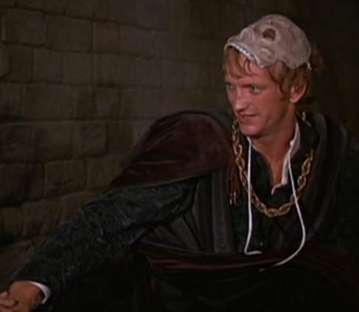

Queen Mab Speech- 1996
Shakespeare Uncovered: Mercutio’s Death
d. Fiennes says that Tybalt is about to “shatter the comedic mood.” How does he do so?
________________________________________________
________________________________________________
________________________________________________
________________________________________________
e. How does the death of Mercutio change the play? How does his death affect Romeo and Juliet as a couple?
________________________________________________
________________________________________________
________________________________________________
________________________________________________________________________________________________
f. Why does Jonathan Bate say that Romeo and Juliet continues to feel so modern?
________________________________________________
________________________________________________
________________________________________________
________________________________________________________________________________________________
Mercutio’s Death- 1968
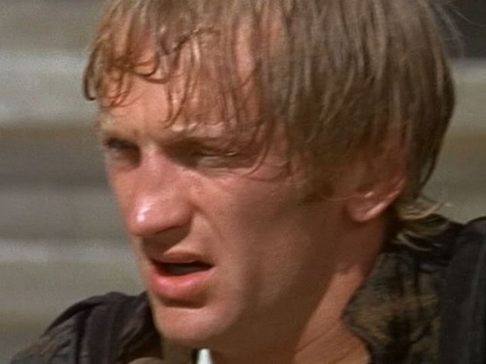

Mercutio’s Death- 1996

