Honors English 9 Summer Assignment: This I Believe Personal Essay
Overview: You will be reading and doing research to help you prepare to write your own This I Believe personal essay. You will be presenting this essay to the class in the first week of school. Hard copies of this packet can be picked up at Wicomico High School’s Guidance Office.
More information will be posted throughout the summer at: http://misswrighteng9.weebly.com/
Honors and AP Guidelines for Summer Assignments Wicomico County:
- Timeframe for Assignment: Total Time 7-11 hours

  - 5-8 hours total for any needed preparation (reading and research)
  - 2-3 hours total for completion of assignment/task

Due Friday September 7th, either electronically via email or hard copy version delivered to Wicomico High School. You may wish to turn the assignment in directly to your teacher during Freshman Back-to-School Night.
Assignments may be submitted electronically via email to Miss Wright, the 9th grade Honors teacher, at: kwright@wcboe.org
Students are expected to present their essay orally to the class along with their visual aids starting Monday, September 10th. The order of presentations will be determined at that time. There will be sessions planned after school during the week of September 4-7 where students may practice their presentations and/or receive coaching from Miss Wright and/or their peers.
- Grading:

  - Grading of summer assignments is to be reflected in the “homework” category for the total course grade, not totaling any more than 10% of the entire “homework” category grade.

- Policy on Transfer Students
- Students enrolling in our high schools from outside our district after August 1st will be “excused” from the summer assignment for any of the AP (or Honors) courses included in the student’s schedule.
  - Students transferring from one of our county high schools to another of our county high schools after August 1st will be given the option of having the summer assignment from their original high school graded/assessed in the new high school.
  - Students changing their schedules to include honors within the first two weeks of school will have two weeks to complete the summer assignment.
- Policy on Late Work

  - Students who are not prepared to turn in and present their assignment by the first day of school will have their grade deducted no more than 10% points.
  - No summer assignments will be accepted after Monday, September 10th.

**Please make sure you dedicate enough time to preparing and completing the assignment and do not wait until the last minute.
Summer Assignment
Formatting for Submission

Before doing the work, save an electronic copy of this document or print a hard copy to include with submission.
All work should be formatted in MLA (Modern Language Association) formatting, which includes:
- 12 point Font, Times New Roman
- Double Spaced** (see note below)
- 1 inch margins
- Heading: Left Side
Your First and Last Name
Wright (Teacher’s Surname)
English 9 Honors (Class Information)
Date (Written: Day Month Year)
- Title Centered: Task and Description of Activity**
- A Works Cited Page with any and all resources you used

For more information about MLA, use the following website https://owl.english.purdue.edu/owl/resource/747/01/

**For the Final Essay, you may choose to single space your essay. It should be one page, single spaced or two pages, double spaced. Not adhering to this will result in grade reduction. You must include a unique title and you may (as an option) include a photo of yourself with or on the essay document. Use the models from the website to decide how you want to organize the essay.

When you complete the activities and tasks, please either email an electronic copy with a cover sheet (saved as your name) OR turn in to the school in a two-pocket folder. If you would like to turn in a hard copy earlier than August 19th, please leave it in the front office labeled to be delivered to Miss Wright.

In the left side of the folder, include this assignment packet, in the right side, include all of your tasks, clipped together in alphabetical order with a paper clip. DO NOT STAPLE. It is expected that all pages will be headed and numbered correctly.

Scoring Rubric for Oral Presentation (First Week of School)

PRESENCE 5 4 3 2 1 0
-body language & eye contact
-contact with the public
-poise
-physical organization

LANGUAGE SKILLS 5 4 3 2 1 0
-correct usage
-appropriate vocabulary and grammar
-understandable (rhythm, intonation, accent)
-spoken loud enough to hear easily

ORGANIZATION 5 4 3 2 1 0
-clear objectives
-logical structure

MASTERY OF THE SUBJECT 5 4 3 2 1 0
-pertinence
-depth of commentary
-spoken, not read

VISUAL AIDS 5 4 3 2 1 0
-transparencies, slides
-handouts
-audio, video, etc.

OVERALL IMPRESSION 5 4 3 2 1 0
-very interesting / very disengaging
-pleasant / unpleasant to listen to
-very good / poor communication

TOTAL SCORE _______ / 30 Activity Itinerary
Task | Time frame | Resources | Points
 |  | Preparation for Assignment (at home)
A. Read or listen to the history of the “This I Believe” and answer the questions. | 30-45 minutes | https://thisibelieve.org/essay/16844/  https://thisibelieve.org/history/ | 10 pts
B. Contrast a personal essay from a personal  narrative and personal memoir. | 1-1.5 hours | http://education.seattlepi.com/difference-between-personal-essay-narrativeessay-2984.html  http://classroom.synonym.com/difference-between-memoir-personalnarrative-1729.html  http://www.writingthroughlife.com/blogtalk-personal-essay-and-memoirwhats-the-difference  https://www.teachervision.com/tv/printables/scottforesman/Math_2_TTM_13.  pdf | 15 pts.
C. Read or listen to sample essays and answer the  questions | 1-2 hours | https://thisibelieve.org/podcasts/  Use the explore tab | 15 pts.
D. Values and Beliefs Writing  Responses | 2 hours | http://freeology.com/journal/values-journal-topics/  http://www.goodreads.com/quotes/tag/values | 10 pts.
E. Planning  Sheet | 1 hour | https://davehood59.wordpress.com/2010/05/05/organizing-a-personalessay/  See Handouts | 10 pts.
 |  | Assignment (at home)
F. Writing Your  Personal  Essay | 1-2 hours | https://thisibelieve.org/guidelines/ | 40 pts.
 |  | Total Points | 100 pts.

Task A: The History of “This I Believe…

Directions: Using the links in the itinerary chart, answer the following questions in complete sentences on a separate sheet of paper. You may choose to answer the main question in one cohesive paragraph or you may choose to answer each question in a separate, complete sentence. Make sure to number each answer. Cite all answers using MLA citations and format using MLA formatting.

What are the origins to “This I Believe”?

- What was the occupation of the man who launched “This I Believe”?

- What was the man’s name?

- What was the theme of the broadcaster’s individual “This I Believe”?

- In what decade was this program launched?

- The initiator of this project describes this time period as the “age of” what?

- What does this project ask of its contributors?

- What was the initial purpose?

- What are some famous people associated with the essays?

- In the excerpt the essays are described as “an invasion of privacy, like demanding a man to let a stranger read his mail.” Why would this project be described that way?

- The speaker/writer says his beliefs are in a state of “flux.” What does “flux” mean?

Task B: Comparing and contrasting
Directions: Use the links on the itinerary page to compare a personal memoir, personal essay, and personal narrative. Complete the Venn Diagram by writing characteristics of each. All information included should be written in complete sentences. When you are finished with the diagram, on a separate sheet, summarize the information in a concise paragraph.
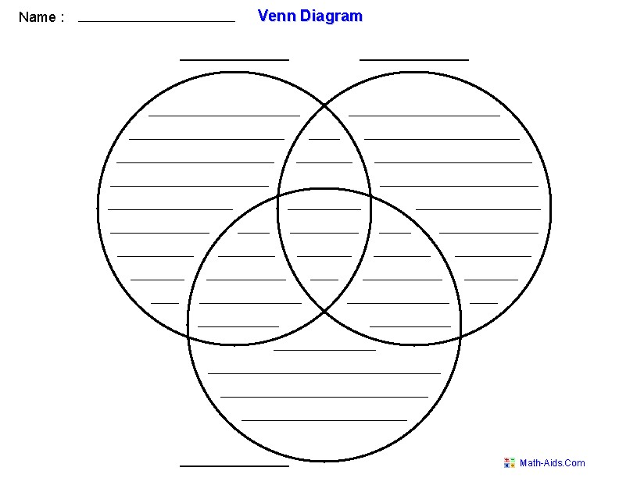

Task C: Exploring “This I Believe” Essays and Broadcasts
Directions: Using the explore tab, read or listen to three essays. You may choose famous people or you may choose regular people. Answer the following questions for each of the three essays. Cite all essays using MLA formatting.

This I Believe #1 Title Author:
Theme/Message/Belief:

This I Believe #2 Title Author:
Theme/Message/Belief

This I Believe #3: Title Author:
Theme/Message/Belief:

On a separate sheet of paper, answer the following questions for each selection

- How does the author “hook” his/her audience in the opening of the essay?
- What type of examples or details does the author use to prove or show his/her ideas?
- How does the author organize his/her paragraphs? What is the purpose of separating paragraphs that way?
- What words are vivid and add voice to the piece?
- Does the author directly tell the audience his/her ideas or does the author show you indirectly?

D: Values and Beliefs
Directions: Read and respond to three quotes and three journal prompts. Each response should be analytical in nature and should reflect your personal beliefs and philosophies. Analytical responses show below surfacelevel meaning and are supported with details and examples that add thought and credibility. Each response should be a minimum of five sentences. Indicate which quotes and scenarios you used for your responses.

Journal Topic Responses-Indicate which topics to which you are responding

1.

2.

3.

Quote Analysis-Indicate which quotes you are analyzing

1.

2.

3.

E: Planning Sheet
Directions: Using the information from the link on the itinerary page, complete the chart below in order to plan for your essay.

 | Notes from Website | For Your Personal Essay
Hook-grabs the reader’s attention | Example:  Personal anecdote
Body-several paragraphs to narrate your story/ideas
Conclusion-the perfect ending when you’re ready to stop
F: Essay and Oral Presentation Rubric (See Formatting Page for more information)
 | 1 | 2 | 3 | 4
Thesis/Focus | Belief statement is not evident. | Multiple beliefs are listed with little development. | Core belief is clearly stated with evidence of development. | One core belief is explicit and developed throughout essay.
Purpose | Tells a story that is not connected to the belief or does not tell a story. | Tells a story that is  somewhat connected to  the belief, but is difficult to follow. | Tells a story that is connected to the belief. | Tells a story that is grounded in the events of everyday life; links to the essence of daily life philosophy and to the shaping of personal beliefs.
Organization  /  Transition | Demonstrates limited or no organization; does not stay on topic; limited or no transitional devices. | Demonstrates ineffective organization; attempts to refer to a single topic; transitional devices are limited. | Demonstrates organization; maintains focus throughout; uses a variety of transitional devices. | Demonstrates unique or effective organization; maintains focus throughout; uses a variety of transitional devices uniquely/effectively.
Details/  Elaboration | Lacks details for the belief or details do not enhance the belief. | Limited use of details; details tell rather than show. | Effective use of relevant details support the belief; details mostly show rather than tell | Unique, rich, insightful, and effective use of details to support belief; details effectively show rather than tell.
Point of View | Uses second person (you) point of view. | Inconsistent use of first-person point of view. | Mostly consistent use of first-person point of view. | Consistent use of first-person point of view.
Writer’s Craft  - Vocabulary  - Voice  - Tone  - Style | - Weak vocabulary; word choice interferes with meaning.  - Lacks writer's voice. • Tone is unclear or negative.  - Limited or no use of  sentence variety. | - Basic or limited vocabulary; some incorrect word choice.  - Emerging sense of voice.  - Tone preaches or judges. • Ineffective use of sentence variety. | - Consistently varied and  effective use of vocabulary;  clear and appropriate  word choice.  - Strong sense of voice.  - Tone is mostly personal and positive.  - Effective use of sentence variety. | - Rich vocabulary, vivid language; sophisticated word choice.  - Powerful sense of voice  throughout piece, appropriate for purpose.  - Tone is consistently personal and positive.  - Effective use of sentence variety to enhance voice and meaning.
Mechanics | Errors seriously interfere with meaning. | Many errors that sometimes interfere with meaning. | Some errors that do not seriously interfere with meaning. | Few errors that do not interfere with meaning.
TOTAL | /56

