Name: __________________________________ Date: ____________________________ Pd. ________
Aristotle’s Tragic Hero: Infographic Assignment
Due Date: _____________________
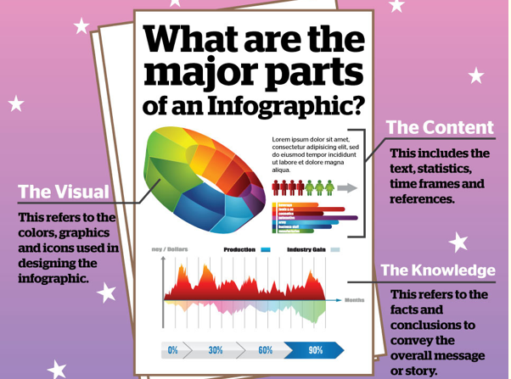
Remember that during the Renaissance, there was a great resurgence of culture from ancient Greece and Rome. Shakespeare's tragedies featured characters who were prime examples of an archetype created by Aristotle known as the tragic hero, and Romeo and Juliet are no exceptions.
Browse the materials on Aristotle’s tragic hero found on our class website, and create an infographic, diagram, flowchart, or poster that captures the essential traits and qualities of a tragic hero and their story arcs and gives at least one example of a tragic hero from literature, drama, cartoons/anime, or film (movie or series).
Be creative. Don't just copy the resources I've provided. Make this assignment your own!
You can use either of the virtual infographic/poster makers I have provided below (each website includes helpful tutorials!), another computer app or program you are familiar with, or use good old-fashioned paper and coloring utensils!
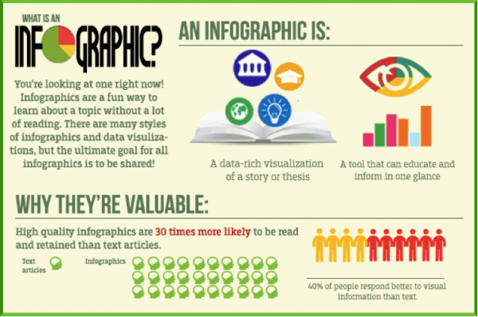

Written Journal Reflection:
Complete this reflection Question in your notebook and bring it to class along with your infographic on the tragic hero on the due date.
Your reflection should be about a paragraph or two in length.
So far, how do Romeo and Juliet fit Aristotle's tragic hero archetype?
What might their fatal flaw(s) be? Cite examples from the Prologue, Act I, or Act II to support your response.
Scoring Rubric
Scoring  Element | Description of Exemplary Work | Score
Accuracy of Information and Demonstration of Understanding | The information presented accurately describes Aristotle’s archetype. Student was able to demonstrate a clear and thorough understanding of the archetype and story lines that contain a tragic hero. The example provided is explained thoroughly and is an accurate representation of the archetype. | _______/10
Completion of Required Elements | Depicted at least three traits/qualities of a tragic hero.  Represented a typical story arc for a tragic hero.  Described a real world or fictional example of a tragic hero and explained how they fit the archetype.  Included both words and visuals. | _______/5  _______/5  _______/5
Creativity and Visual Aesthetic | Information was arranged in an organized and logical manner so that concepts being presented could be clearly understood. Attention was given to conventions in writing. Space was used effectively. Infographic is colorful and visually pleasing. Student creatively represented their learning. | _______/5
TOTAL |  | _______/30
Comments:

Written Reflection | Responded to the prompt in a thorough and thoughtful manner. Connections to Romeo and Juliet were accurate and evidence provided was relevant to the claims made in the response. Attention was given to conventions in writing. | _______/10

